Samantha Riedener

IST 718 Week 6 Lab

Time series plot for select Arkansas metro areas:

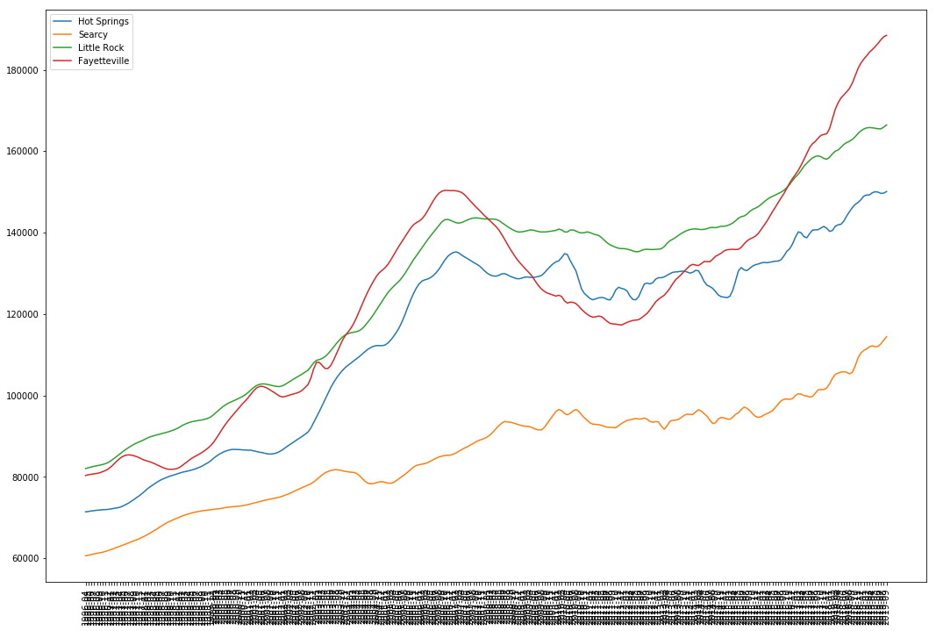

What 3 zip codes provide the best investing opportunities for SREIT?

Since this is a Syracuse based investing trust, the zip codes in the Buffalo, Rochester, and Syracuse areas will be explored to keep the firm local.

Predictions for zip codes in each area were made and compared. The top three zip codes for each area are as follows:

Rochester:

14506 - $279567.607577

14564 - $288622.965734

14534 - $289815.404233

Syracuse:

13078 - $245495.448452

13104 - $250703.997888

13152 - $383089.937661

Buffalo:

14068 - $304573.528742

14031 - $312454.571798

14051 - $344852.763839

The trends for these top zip codes were then further investigated to see which ones had the smallest range of uncertainty around the predictions in the data.

14506

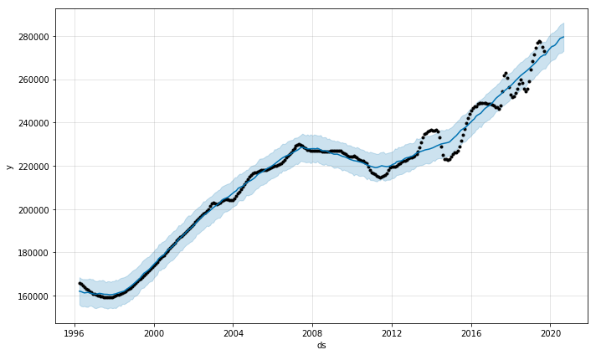

14564

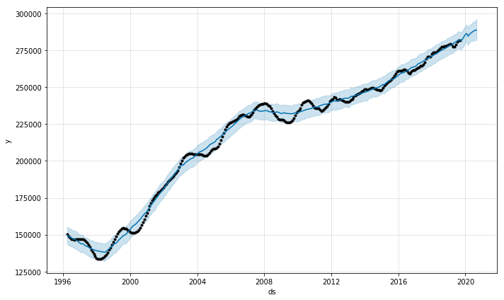

14534

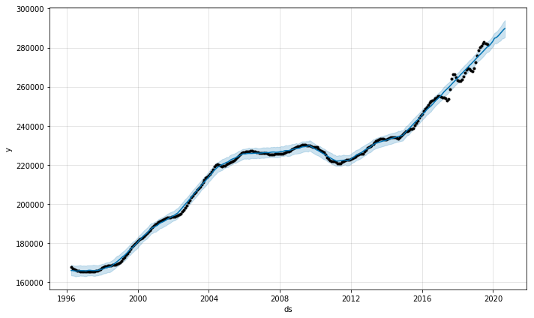

13078

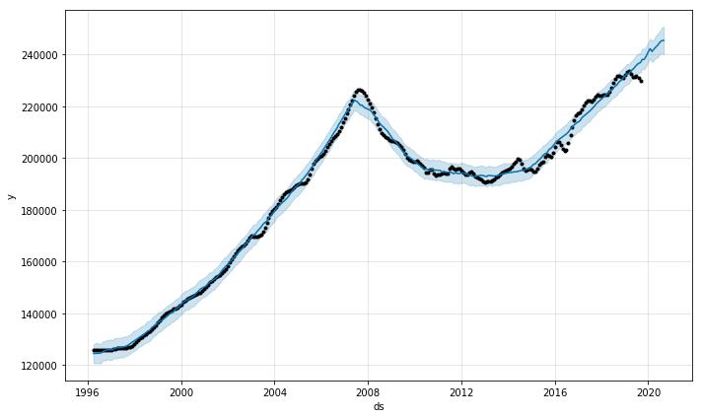

13104

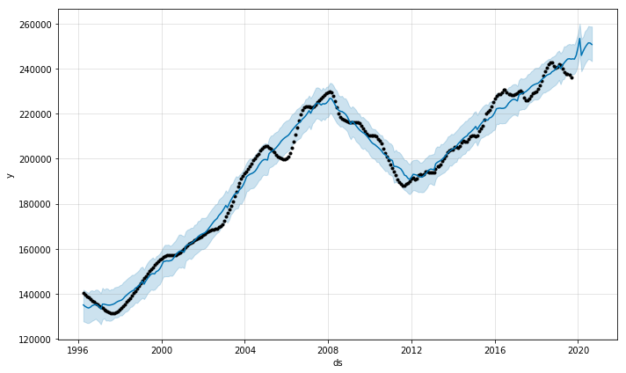

13152

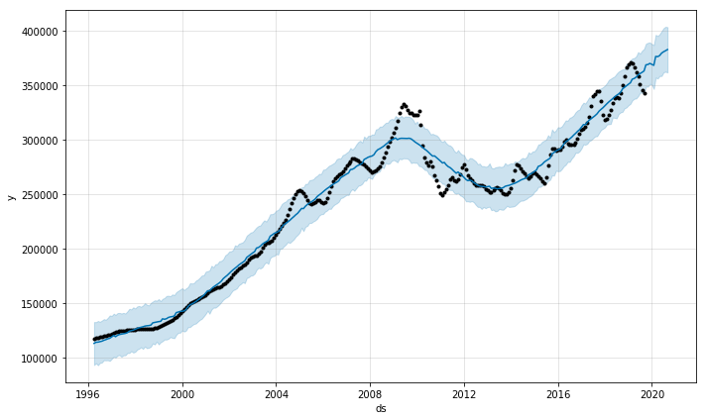

14068

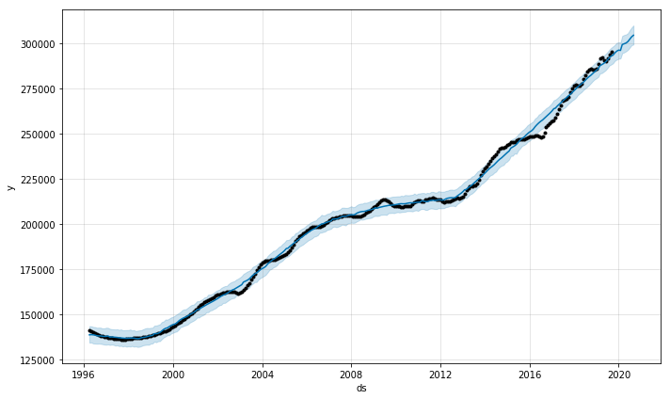

14031

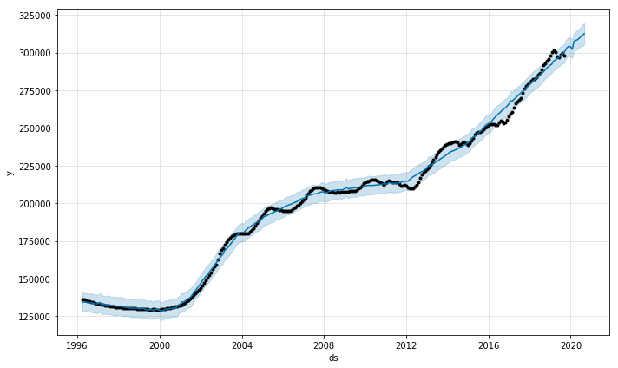

14051

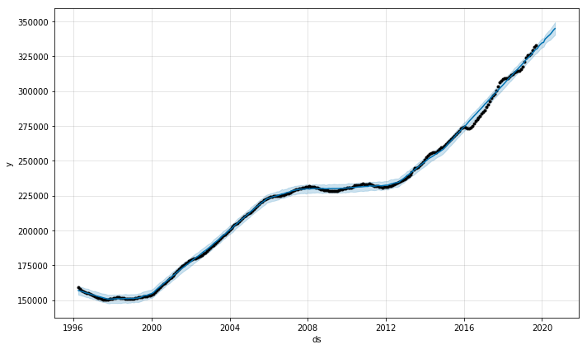

Not only were the Buffalo zip codes higher than the other two cities’ top zip codes (except for one Syracuse zip code) they also showed the least uncertainty in their predictions and the least variability across time. They were relatively unaffected by the 2008 housing market crash and would therefore hopefully perform similarly in the future if the same sort of conditions came about in the future.

Based on the performed analysis the three recommended zip codes are 14068, 14031, and 14051.